I/We, _______________________________________, pursuant to Idaho Code 39-4802 (2) and IDAPA 16.02.15.110
I/we submit this signed statement to the school

_________________________________________________________
officials objecting to immunizations on religious OR other grounds for our child __________________________________________.
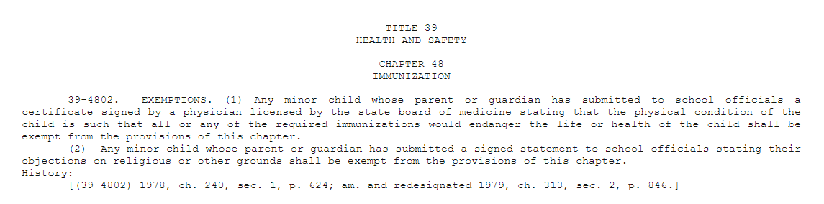
Statute 39-4802

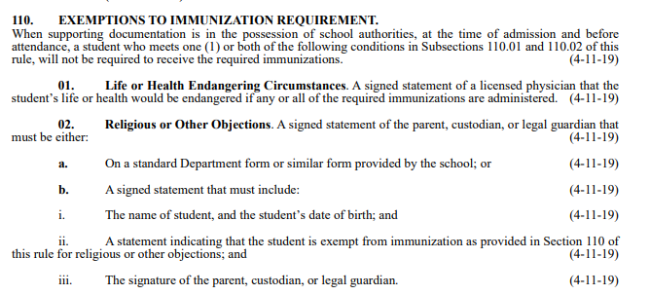
IDAPA 16.02.15.110

